be ethical. stay ethical. reward ethical.

Registration Form – Date:

This is a registration form, once completed it must be saved in pdf, signed and emailed.

We feel people should be rewarded for being ethical and our card does exactly that. Non profit.

Businesses are rewarded with loyalty and exposure.

Members are rewarded with discounts and similar perks.

Helps fund: Other plant based, conscious and sustainable projects. It’s Ethical Innovation.

Participation terms:
You must be a supplier of pro ethical, plant based or sustainable goods or services.
We only request a reward term to be imposed on the goods or services that you offer that meet the above criteria.
We kindly request that you will agree to display a pre-agreed amount of marketing materials to advertise that you are part of Tru.

Proposed Launch date: Jan/Feb 2019

Business details | Business name:  Business address:  Contact number:  What do you sell?
Card launch date | Jan/Feb 2019
The benefits | Benefits:  - Free advertising on our website  - Free linked directory entry on our website  - Sell in store and receive 20% back  - Discounted access to attend Tru associated events and festivals.
Participation Terms | Agreed Terms  We would like to offer _____ %* discount off all /some** products. (please circle)  Please tick/state:  - Cruelty free  - Vegan products/ services  - Vegetarian products/ services  - Organic products/ services (SOIL ASSOCIATION Certified)  - Fair Trade products/ services  - Locally Sourced products  - Sustainably sourced (Eco-friendly) products  - Other products  - Other services (E.g. Wellbeing related)  If other please state:  *Minimum 10% discount. Recommended 15% - 25%.  **We will email you at a later date to confirm exactly which products/services  - Are you happy to be a Tru distributor and earn 20% of each card sold via your business? Yes*/No  - Tru is a trademark The Truprint Group - a non profit social-ethical impact company.  All funds generated will directed through The Truprint Group and its non profit projects and objectives.  Terms & Conditions:  - I agree and understand that as a participating proprietor I will be expected to allow the placing of marketing materials such as posters and flyers in the areas of my businesses to which this discount applies.  - All cards have a 14 days refund policy. I agree to read the full terms and conditions via thetruprintgroup.org within 7 days of agreeing to the terms laid out in this document, by which time the agreement will come into full effect.  - If I wish to end the agreement, I will email my request to info@thetruprintgroup.org no less than 30 days before the date I wish it to come into effect.
Sign up costs  (Office to specify only, with signature to authorise) | FREE introductory offer  £25 per annum
Payments | Payment:  We expect an upfront payment per annum of £25 to be a participating proprietor benefitting from the exposure and loyalty the card brings. It also means you automatically receive Tru accreditation status as an ethical supplier.  We will also receive payment through proprietors who decide to sell the card and we expect an electronic payment of the sum of these sales by the last working day of each month. The 20% cashback earnt will be calculated and returned to you within 10 working days of receiving your payment.*  Payment details:  Account Name: The Truprint Group  Account: 37701460  Sort code: 30-90-89  *A separate agreement of terms will be provided if you opt in to become a distributor.
Proposed design  Subject to change. | Front: A transparent/frosted card  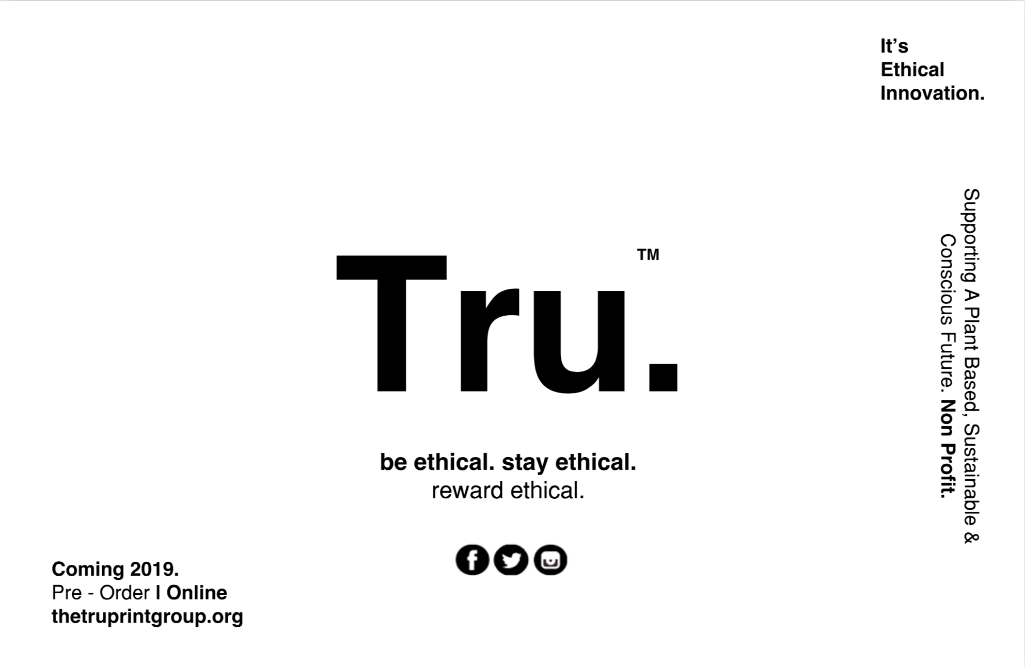  Back/ Security: Will have a white signature square on the back where we may indicate the expiry date and name – behind the “T”
Benefits & Prices | Membership scope:  Provide members access to exclusive offers at shops, food, gyms, wellbeing, events, trips and festivals.  As a by-product it provides members with a comprehensive consumer guide to living more ethically in their local area.  Membership prices: (1 year)  Concession: £7 or £5 promo  Normal: £10 or £7 promo

I can confirm that I have legal right to agree and sign into these terms on behalf of the named business above and that I have read the above details, terms and conditions.

Name:

Signature:

Strictly Confidential - Content of this document is property of The Truprint Group and is not to be shared with any persons or entities outside of the organisation.

